**Library Management System using SQL Project**

**Project Overview:**

**Project Title:** Library Management System  
**Database:** library

This project demonstrates the implementation of a Library Management System using SQL. It includes creating and managing tables, performing CRUD operations, and executing advanced SQL queries. The goal is to showcase skills in database design, manipulation, and querying.

**Objectives**

1. Set up the Library Management System Database: Create and populate the database with tables for branches, employees, members, books, issued status, and return status.
2. CRUD Operations: Perform Create, Read, Update, and Delete operations on the data.
3. CTAS (Create Table As Select): Utilize CTAS to create new tables based on query results.
4. Advanced SQL Queries: Develop complex queries to analyze and retrieve specific data.

**Project Structure**

**1. Database Setup**

**[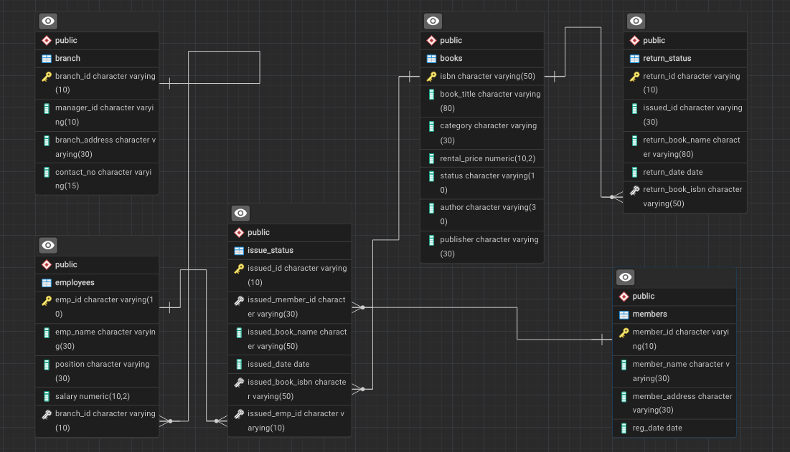](https://github.com/najirh/Library-System-Management---P2/blob/main/library_erd.png)**

* **Database Creation: Created a database named library.**
* **Table Creation: Created tables for branches, employees, members, books, issued status, and return status. Each table includes relevant columns and relationships.**

CREATE DATABASE library;

DROP TABLE IF EXISTS branch;

CREATE TABLE branch

(

branch_id VARCHAR(10) PRIMARY KEY,

manager_id VARCHAR(10),

branch_address VARCHAR(30),

contact_no VARCHAR(15)

);

**--Create table "Employee"**

DROP TABLE IF EXISTS employees;

CREATE TABLE employees

(

emp_id VARCHAR(10) PRIMARY KEY,

emp_name VARCHAR(30),

position VARCHAR(30),

salary DECIMAL(10,2),

branch_id VARCHAR(10),

FOREIGN KEY (branch_id) REFERENCES branch(branch_id)

);

**-- Create table "Members"**

DROP TABLE IF EXISTS members;

CREATE TABLE members

(

member_id VARCHAR(10) PRIMARY KEY,

member_name VARCHAR(30),

member_address VARCHAR(30),

reg_date DATE

);

**-- Create table "Books"**

DROP TABLE IF EXISTS books;

CREATE TABLE books

(

isbn VARCHAR(50) PRIMARY KEY,

book_title VARCHAR(80),

category VARCHAR(30),

rental_price DECIMAL(10,2),

status VARCHAR(10),

author VARCHAR(30),

publisher VARCHAR(30)

);

**-- Create table "IssueStatus"**

DROP TABLE IF EXISTS issued_status;

CREATE TABLE issued_status

(

issued_id VARCHAR(10) PRIMARY KEY,

issued_member_id VARCHAR(30),

issued_book_name VARCHAR(80),

issued_date DATE,

issued_book_isbn VARCHAR(50),

issued_emp_id VARCHAR(10),

FOREIGN KEY (issued_member_id) REFERENCES members(member_id),

FOREIGN KEY (issued_emp_id) REFERENCES employees(emp_id),

FOREIGN KEY (issued_book_isbn) REFERENCES books(isbn)

);

**-- Create table "ReturnStatus"**

DROP TABLE IF EXISTS return_status;

CREATE TABLE return_status

(

return_id VARCHAR(10) PRIMARY KEY,

issued_id VARCHAR(30),

return_book_name VARCHAR(80),

return_date DATE,

return_book_isbn VARCHAR(50),

FOREIGN KEY (return_book_isbn) REFERENCES books(isbn)

);

**2. CRUD Operations**

* Create: Inserted sample records into the books table.
* Read: Retrieved and displayed data from various tables.
* Update: Updated records in the employees table.
* Delete: Removed records from the members table as needed.
* **Task 1.** Create a New Book Record -- "978-1-60129-456-2', 'To Kill a Mockingbird', 'Classic', 6.00, 'yes', 'Harper Lee', 'J.B. Lippincott & Co.'"

INSERT INTO books(isbn, book_title, category, rental_price, status, author, publisher)

VALUES('978-1-60129-456-2', 'To Kill a Mockingbird', 'Classic', 6.00, 'yes', 'Harper Lee', 'J.B. Lippincott & Co.');

SELECT * FROM books;

* **Task 2:** Update an Existing Member's Address

UPDATE members

SET member_address = '125 Oak St'

WHERE member_id = 'C103';

* **Task 3:** Delete a Record from the Issued Status Table

 -- Objective: Delete the record with issued_id = 'IS121' from the issued_status table.

DELETE FROM issued_status

WHERE issued_id = 'IS121';

* **Task 4:** Retrieve All Books Issued by a Specific Employee

-- Objective: Select all books issued by the employee with emp_id = 'E101'.

SELECT * FROM issued_status

WHERE issued_emp_id = 'E101'

* **Task 5:** List Members Who Have Issued More Than One Book

-- Objective: Use GROUP BY to find members who have issued more than one book.

SELECT

issued_emp_id,

COUNT(*)

FROM issued_status

GROUP BY 1

HAVING COUNT(*) > 1

**3. CTAS (Create Table As Select)**

* **Task 6:** Create Summary Tables: Used CTAS to generate new tables based on query results - each book and total book_issued_cnt**

CREATE TABLE book_issued_cnt AS

SELECT b.isbn, b.book_title, COUNT(ist.issued_id) AS issue_count

FROM issued_status as ist

JOIN books as b

ON ist.issued_book_isbn = b.isbn

GROUP BY b.isbn, b.book_title;

**4. Data Analysis & Findings**

**The following SQL queries were used to address specific questions:**

* **Task 7.** Retrieve All Books in a Specific Category:

SELECT * FROM books

WHERE category = 'Classic';

Task 8: Find Total Rental Income by Category:

SELECT

b.category,

SUM(b.rental_price),

COUNT(*)

FROM

issued_status as ist

JOIN

books as b

ON b.isbn = ist.issued_book_isbn

GROUP BY 1

* **Task 9.** List Employees with Their Branch Manager's Name and their branch details:

SELECT

e1.emp_id,

e1.emp_name,

e1.position,

e1.salary,

b.*,

e2.emp_name as manager

FROM employees as e1

JOIN

branch as b

ON e1.branch_id = b.branch_id

JOIN

employees as e2

ON e2.emp_id = b.manager_id

Task 10. Create a Table of Books with Rental Price Above a Certain Threshold:

CREATE TABLE expensive_books AS

SELECT * FROM books

WHERE rental_price > 7.00;

Task 11: Retrieve the List of Books Not Yet Returned

SELECT * FROM issued_status as ist

LEFT JOIN

return_status as rs

ON rs.issued_id = ist.issued_id

WHERE rs.return_id IS NULL;

**Advanced SQL Operations**

* **Task 12:** Identify Members with Overdue Books  
  Write a query to identify members who have overdue books (assume a 30-day return period). Display the member's_id, member's name, book title, issue date, and days overdue.

SELECT

ist.issued_member_id,

m.member_name,

bk.book_title,

ist.issued_date,

-- rs.return_date,

CURRENT_DATE - ist.issued_date as over_dues_days

FROM issued_status as ist

JOIN

members as m

ON m.member_id = ist.issued_member_id

JOIN

books as bk

ON bk.isbn = ist.issued_book_isbn

LEFT JOIN

return_status as rs

ON rs.issued_id = ist.issued_id

WHERE

rs.return_date IS NULL

AND

(CURRENT_DATE - ist.issued_date) > 30

ORDER BY 1;

* **Task 13**: Update Book Status on Return  
  Write a query to update the status of books in the books table to "Yes" when they are returned (based on entries in the return_status table).

SELECT * FROM issued_status

WHERE issued_book_isbn = '978-0-451-52994-2';

-- IS104

SELECT * FROM books

WHERE isbn = '978-0-451-52994-2';

UPDATE books

SET status = 'no'

WHERE isbn = '978-0-451-52994-2';

SELECT * FROM return_status

WHERE issued_id = 'IS130';

UPDATE books

SET status = 'yes'

WHERE isbn = '978-0-451-52994-2';

--

INSERT INTO return_status(return_id, issued_id, return_date)

VALUES

('RS125', 'IS130', CURRENT_DATE);

SELECT * FROM return_status

WHERE issued_id = 'IS130';

* **Task 14:** Branch Performance Report  
  Create a query that generates a performance report for each branch, showing the number of books issued, the number of books returned, and the total revenue generated from book rentals.

CREATE TABLE branch_reports

AS

SELECT

b.branch_id,

b.manager_id,

COUNT(ist.issued_id) as number_book_issued,

COUNT(rs.return_id) as number_of_book_return,

SUM(bk.rental_price) as total_revenue

FROM issued_status as ist

JOIN

employees as e

ON e.emp_id = ist.issued_emp_id

JOIN

branch as b

ON e.branch_id = b.branch_id

LEFT JOIN

return_status as rs

ON rs.issued_id = ist.issued_id

JOIN

books as bk

ON ist.issued_book_isbn = bk.isbn

GROUP BY 1, 2;

SELECT * FROM branch_reports;

**Task 15: Find Employees with the Most Book Issues Processed  
Write a query to find the top 3 employees who have processed the most book issues. Display the employee name, number of books processed, and their branch.**

**SELECT**

**e.emp_name,**

**b.*,**

**COUNT(ist.issued_id) as no_book_issued**

**FROM issued_status as ist**

**JOIN**

**employees as e**

**ON e.emp_id = ist.issued_emp_id**

**JOIN**

**branch as b**

**ON e.branch_id = b.branch_id**

**GROUP BY 1, 2**

**Reports**

* **Database Schema: Detailed table structures and relationships.**
* **Data Analysis: Insights into book categories, employee salaries, member registration trends, and issued books.**
* **Summary Reports: Aggregated data on high-demand books and employee performance.**

**Conclusion**

**This project demonstrates the application of SQL skills in creating and managing a library management system. It includes database setup, data manipulation, and advanced querying, providing a solid foundation for data management and analysis.**

**Thank you for your interest in this project!**